Understanding the Façade Design Pattern in Real-time Example:
Let us understand the Façade Design Pattern with one real-time example. Please have a look at the following diagram. Here, we need to design an application to place an order.
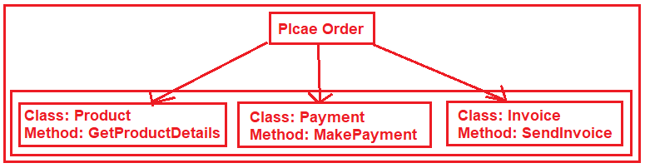
As shown in the above image, in order to place an order first we need to create an object of Product class and get the product details. Then if everything is fine then we need to make the Payment and in order to do this, we need to create an instance of the Payment class and call the MakePayment method. If Payment is successful then we need to send the Invoice to the customer. So, in order to place the order, we need to do the above mention steps.
The Façade is actually an extra class that lies at the top of the above method class.
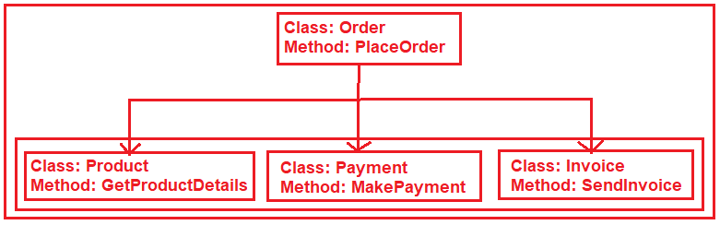
So, here the extra class Order is the Façade class which will take the responsibility of placing the order. This class internally creates the instance of the respective classes and calls the method.

